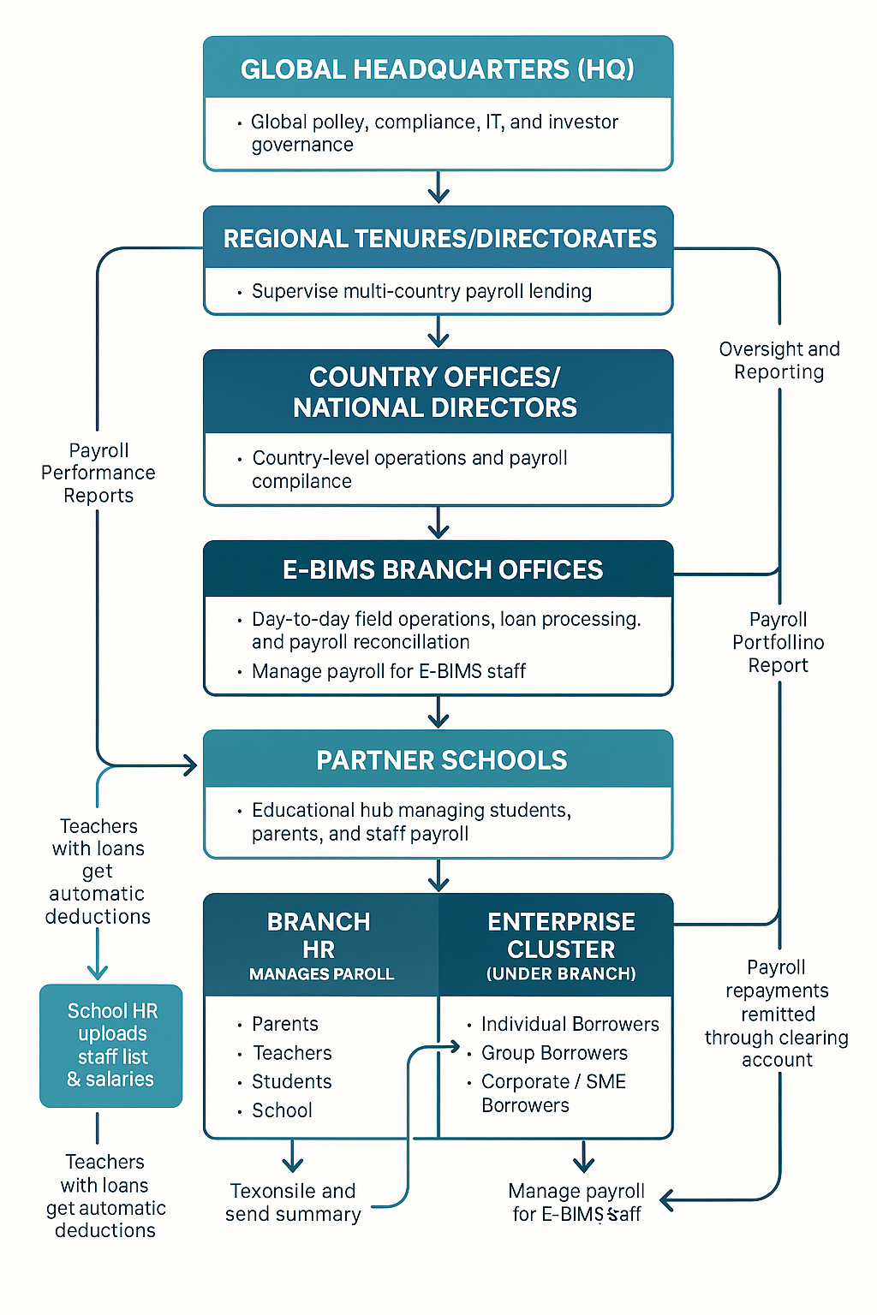

🏗 Developer’s Architectural Outflow
E-BIMS Global Partnership, Lending, and Payroll Platform
We’ll break it into 6 stacked layers (HQ → Regional → Country → Branch → School → Clients) and then map the technical services and data flow across those layers.

1. Platform Modules (Core Systems To Build)
These are the major application modules. Every feature you’ve defined lives in one of these.
- Identity & Access Module (IAM)
  - Users: HQ Admin, Regional Director, Country Officer, Branch Staff, School Super Admin, Bursar, HR Officer, Parent, Teacher, Borrower, Group Rep.
  - Features:
    - Role-based access control (RBAC)
    - Region / Country / Branch scoping
    - Multi-tenant separation across countries and schools
    - Audit trails
- School Management Module
  - Stores school profile
  - Uploads Ministry of Education registration, DEO letter, operating license
  - Stores fee structure per term
  - Holds student rosters, parent contacts, teacher/staff payroll roster
  - Owned day-to-day by: School Super Admin + Branch
- Loan Origination & Credit Module
  - Parent fee-loan applications
  - Teacher salary advance and payroll-linked loans
  - SME / group / corporate loan applications
  - KYC / credit scoring / approval workflow
  - Policy constraints injected from HQ, enforced at Country and Branch level
- Disbursement & Collections Module
  - Wallet debit authorization flow after approval
  - Full 100% fee disbursement directly to school
  - Loan repayment schedules
  - Mobile money / wallet reconciliation
  - Bank clearing accounts for branch and school
  - Transaction fee tracking (UGX 2,000 etc.)
- Payroll Module
  - HR upload (teacher/staff list, salary, deductions)
  - Branch payroll officer reconciliation
  - Automatic salary deduction for loan repayment
  - Corporate/SME payroll integration for enterprise borrowers
  - Remittance logging and compliance reporting
  - Supports both:
    - School payroll channel
    - Branch/enterprise payroll channel
- Insurance & Risk Module
  - Links each approved loan to insurance coverage (5% insurance fee)
  - Stores policy certificate
  - Tracks claim triggers: death, disability, job loss
  - Flags non-performing loans and escalates to claim
- Reporting & Regulatory Module
  - Compliance dashboards by country
  - Regenerative impact dashboards by region
  - Branch portfolio quality / payroll performance
  - Donor/investor summary rollups (HQ view)
  - Export packs for MoES, UMRA, district education offices

2. Logical Layer Stack (Who Operates Which Layer)
Tier 1 – Global Headquarters Layer
Primary Responsibilities (Tech View):
- Sets global policy rules that cascade down (interest caps, insurance policy models, allowed products).
- Runs the global identity directory (top of RBAC tree).
- Maintains master reporting warehouse (global data lake).
Core Services Running Here:
- ❖ Policy Engine Service
- ❖ Compliance Rules Service
- ❖ Global Reporting Warehouse / BI
- ❖ Audit & Governance Service
Data flows OUT of HQ:
Policy configs, lending criteria, compliance thresholds, reporting templates.
Data flows INTO HQ:
Performance metrics, loan health, repayment rates, payroll deduction performance, impact KPIs, by region.

Tier 2 – Regional Tenure Layer
(Example: East Africa Tenure, Central America Tenure)
Primary Responsibilities (Tech View):
- Regional aggregation.
- Localization of HQ policy to regional norms.
- Escalation point between Country Offices and HQ.
Core Services Running Here:
- ❖ Regional Compliance Adapter
  - “Here’s how Uganda, Kenya, Tanzania differ on payroll deduction law.”
- ❖ Regional Analytics Node
  - Summaries by country: portfolio at risk, repayment %, payroll repayment %, disbursement volume.
Data flows OUT of Region:
Validated, normalized country reports → HQ.
Data flows INTO Region:
Policy updates → which then get translated for each country.

Tier 3 – Country Office Layer
(Example: Uganda Country Office)
Primary Responsibilities (Tech View):
- Country-specific compliance and licensing validation.
- School verification (MoES reg forms, DEO letter, school license).
- Approval to onboard school into system.
- Final credit approval rules under national law.
- Payroll legality (labor law, deduction limits).
Core Services Running Here:
- ❖ KYC & School Verification Service
  - Stores scans of DEO letters, MoES registration.
- ❖ Country Compliance Service
  - Enforces local caps (max deduction % of salary, etc.).
- ❖ Regulator Reporting Exporter
  - Generates UMRA / MoES / taxation-ready summary packets.
Data flows OUT of Country:
- Approved school metadata → Branch.
- Compliance status → Region.
- Regulatory reporting signals → HQ (for audit trail).
Data flows INTO Country:
- Branch activity logs (loans issued, payroll deductions, arrears).
- HQ / Regional policy constraints.

Tier 4 – Branch Layer (District / City Branch)
This is the operational heart. This is where it all becomes real.
Primary Responsibilities (Tech View):
- Operates both “Education Channel” and “Enterprise Channel.”
- Handles parent fee-loan intake and teacher payroll loans.
- Onboards SMEs, group borrowers, individual micro-borrowers.
- Manages payroll for partner schools AND (optionally) corporate/SME partners.
- Handles arrears follow-up, restructuring, on-the-ground recovery.
Core Services Running Here:
- ❖ Branch Loan Desk Portal
  - For Credit Officers to process applications.
- ❖ Payroll Reconciliation Console
  - For Branch Payroll Officer to import school HR files, mark deductions received, flag gaps.
- ❖ Collections & Recovery Dashboard
  - Repayment status, delinquency flags, follow-up tasks.
- ❖ Wallet/Disbursement Gateway Connector
  - Calls out to mobile money / bank rails.
Data flows OUT of Branch:
- Loan status, repayments, payroll deduction summaries → Country Office.
- Alerts (defaults, fraud risk, school non-cooperation).
Data flows INTO Branch:
- Approved school list from Country Office.
- Policy constraints from HQ/Region/Country.
- Roster + payroll files from School Super Admin and HR.

Tier 5 – School Layer (Super Admin Node)
This layer behaves like a sub-tenant / sub-organization inside the platform.
Primary Responsibilities (Tech View):
- Maintains live roster: students, parents/guardians, teachers/staff.
- Publishes fee structure per term.
- Confirms fee loan disbursement for each learner (yes, this student is enrolled, yes this is the real fee).
- Runs payroll upload to trigger salary deductions for teachers with loans.
Core Interfaces / Microfrontends Here:
- ❖ School Admin Dashboard
  - Upload staff payroll CSV / XLS
  - Upload student list / fees
  - Confirm “Paid via E-BIMS loan”
- ❖ Teacher / Staff Portal
  - Request salary advance
  - See outstanding balance and deduction schedule
- ❖ Parent Portal (school-facing view)
  - See fee amount
  - Track “Paid by E-BIMS” status
Data flows OUT of School:
- Payroll deduction files → Branch Payroll Reconciliation Console.
- Student fee confirmation → Branch Loan Desk Portal.
- Termly performance reports → Branch (for monitoring and impact scoring).
Data flows INTO School:
- Disbursement confirmations (this child’s fees paid in full).
- Deduction schedules for each teacher’s loan.
- Messaging from Branch about arrears or compliance.

Tier 6 – Client Layer (End Users)
We have two clusters, and engineering needs to keep them logically separate:
6A. Education Cluster (under School node)
- Parents / Guardians
- Teachers / Staff
- Students
- School Entity (as borrower)
Use cases:
- Apply for school fees loan.
- Approve wallet debit (after approval).
- Receive full school fee disbursement on behalf of child.
- Teachers request salary advance.
- Salary repayment happens through automated payroll deduction.
- School as institution can request infrastructure / bridge financing.
6B. Enterprise Cluster (under Branch node)
- Individual borrowers (micro / personal working capital)
- Group borrowers (SACCO, village group, church group, teachers’ circle)
- Corporate / SME borrowers
Use cases:
- Apply for business / equipment / working capital credit.
- Some repayments come from their own payroll (if formal employer is integrated with Branch).
- Repay via wallet / mobile money / branch cash window.
- Groups can generate pooled repayment schedules.
Front-end experiences here:
- ❖ Client Mobile App / USSD / Agent UI
  - View outstanding balance, repayment calendar
  - Authorize wallet debit fees (registration fee 50,000; 5% admin; 5% insurance; etc.)
  - Get receipts
  - See insurance certificate
Data flows OUT of Clients:
- Loan applications, consent to payroll deduction, repayment transactions, hardship/appeal requests.
Data flows INTO Clients:
- Repayment reminders
- Digital receipts
- Status: “Paid via E-BIMS Loan,” “Payroll deduction scheduled,” etc.

3. Event & Data Flow Summary (Developer View)
Core Event Chain for a Parent School Fees Loan
- School Super Admin verifies student & fee → pushes that to Branch Loan Desk.
- Branch Credit Officer runs credit scoring in Loan Origination Module.
- Country Compliance Service validates KYC / legal.
- Loan = Approved.
- Client App prompts parent: “Confirm wallet debit for registration (50,000), admin (5%), insurance (5%).”
- After confirmation, Disbursement Module pays full fees directly to the school’s bank/E-BIMS settlement account.
- Insurance Module activates cover.
- Collections Module starts repayment schedule and links it either to:
  - mobile wallet installments, or
  - payroll deduction if the parent is also staff.
All transactional and compliance records replicate upward:
- Branch → Country Office → Regional → HQ (data warehouse).

4. Developer Priorities by Milestone (Recommended Build Order)
Milestone 1: Core Rails
- Identity & Access (RBAC, multi-tenant by Branch / School)
- School Management (upload roster, fees)
- Loan Origination + Approval Flow (parent loan, teacher loan)
- Disbursement & Wallet Debit Flow (no manual cash handling)
Milestone 2: Branch Ops
- Branch Loan Desk Portal
- Collections & Repayment Dashboard
- Payroll Reconciliation Console (upload payroll, mark who got deducted)
Milestone 3: Country / Regional / HQ Layer
- Compliance dashboards (license validity, DEO letter tracking)
- Automated reporting roll-up
- Policy engine where HQ can push lending rules down
Milestone 4: Insurance + Impact
- Insurance API
- Claim trigger workflow
- Impact/ESG dashboard for donors (students kept in school, teachers supported, SMEs stabilized)

5. How This All Relates for Engineering and Product
- HQ needs: analytics, control, auditability → this means global reporting warehouse + policy engine are not optional.
- Regional needs: roll-up dashboards per tenure → this means region-scope aggregation views.
- Country needs: compliance and licensing screens → this means document upload, approval states, and regulatory export.
- Branch needs: operational tooling → this is your front line. Branch cannot run on spreadsheets.
- School needs: self-serve portal with payroll upload → this is where we must be very easy to use or the model breaks.
- Clients need: trust, clarity, receipts, dignity → mobile/USSD experience must be simple, multilingual, and fast.

This is the full Developer’s Architectural Outflow:
- Who owns which layer
- Which system lives at each layer
- Which data flows between them
- And the build order to ship this as a real platform.

